**23CSE111**

**OBJECT ORIENTED PROGRAMMING**

**LAB LAB MANUAL**



**Department of computer science and Engineering**

**Amrita School of Engineering**

**Amrita Vishwa Vidyapeetham, Amaravati Campus**

SUBMITTED FROM: SUBMITTED TO:

|  |  |  |  |
| --- | --- | --- | --- |
| NAME | **S.SOHAIL** | **NAME** | **RAJ KUMAR BATTU** |
| ROLL NO | **AV.SC.U4CSE**24319 | **DEPARTMAENT** | **OOPS** |
| SECTION | **CSE-B** | **DESIGNATION** | **PROFESSOR** |

|  |  |
| --- | --- |
| MARKS |  |
| SIGNATURE |  |
| DATE |  |

INDEX

|  |  |  |  |  |
| --- | --- | --- | --- | --- |
| Si.no | Name of programme | Date | Page no | Signature |
| 1. | Week 1  Inastalation of java |  | 3-5 |  |
| 2. | Printing student details |  | 6-7 |  |
| 3. | Week 2  Calculating area of rectangle |  | 8-9 |  |
| 4. | Temperature convertion from C0 to F0  and F0  to C0 |  | 10-13 |  |
| 5. | Calculating Simple Interest |  | 13-15 |  |
| 6. | Finding greatest of three numbers |  | 15-16 |  |
| 7. | Factorial of a number |  | 16-18 |  |
|  |  |  |  |  |
|  |  |  |  |  |
|  |  |  |  |  |
|  |  |  |  |  |
|  |  |  |  |  |
|  |  |  |  |  |
|  |  |  |  |  |
|  |  |  |  |  |
|  |  |  |  |  |
|  |  |  |  |  |
|  |  |  |  |  |
|  |  |  |  |  |
|  |  |  |  |  |
|  |  |  |  |  |
|  |  |  |  |  |
|  |  |  |  |  |
|  |  |  |  |  |
|  |  |  |  |  |
|  |  |  |  |  |

**WEEK-1**

1.How to install java jdk?

A. **1.Steps for downloading.**

Step 1: Java is developed by oracle. so open your web browser and search for java oracle.

Step 2: Then go to the website <https://www.oracle.com/in/java/> .

Step 3: And navigate to the java downloads. Then some earlier versions are available like

* [**JDK 23**](https://www.oracle.com/in/java/technologies/downloads/#java23)
* [**JDK 21**](https://www.oracle.com/in/java/technologies/downloads/#java21)
* [**GraalVM for JDK 23**](https://www.oracle.com/in/java/technologies/downloads/#graalvmjava23)
* [**GraalVM for JDK 21**](https://www.oracle.com/in/java/technologies/downloads/#graalvmjava21)

Step 3: JDK 21 is the latest *Long-Term Support (LTS)* release of the Java SE Platform. So we use this version.

Step 4: According to your device operating system choose the product/file description.

Step 5: Then the version will be automatically downloaded.

**2.Steps for installation.**

Step 1: Go to the folder where it was downloaded.

Step 2: Then open and accept all terms and conditions.

Step 3: And install it.

**3.Setting environmental variables.**

Step 1: Open file explorer, then right click on This PC next select on properties then it will take you to the settings app then click on advanced system settings and then click on **Environment Variables**.

Step 2: Click **New** under **System Variables**:

* + 1. **Set Variable name as:** java_home
    2. **Variable value:** The folder address where JDK is installed (like C:\Program Files\Java\jdk-21\bin)

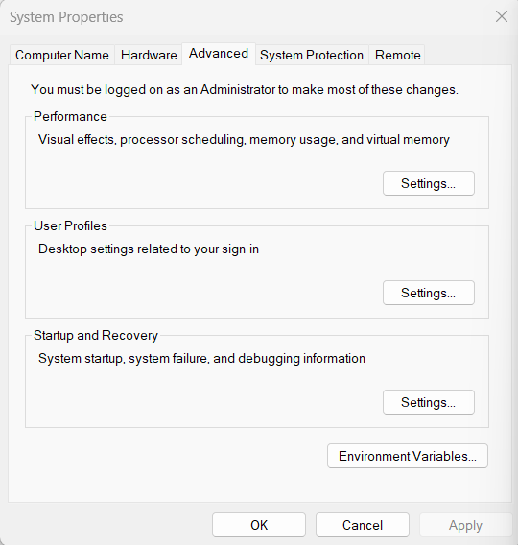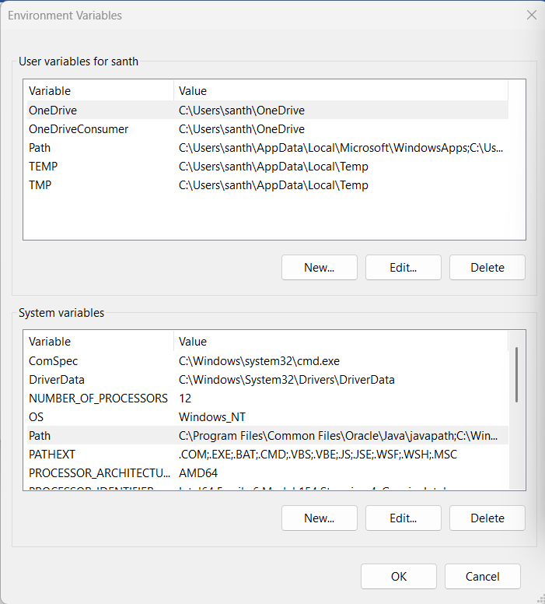Step 3: Find Path under **System Variables**, click **Edit**, and add the path of the jdk-21(C:\Program Files\Java\jdk-21\bin)

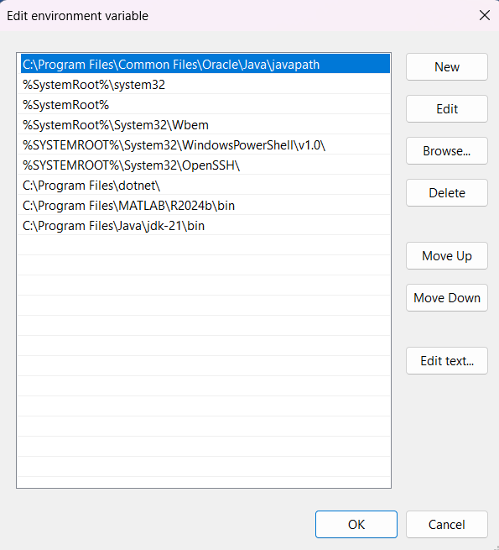

**4.Checking for jdk(java development kit) version.**

Step 1: Open command promt.

Step 2: Enter javac --version for version of jdk installed.

Step 3: Enter java –version for all details like when downloaded and path of environment variables.

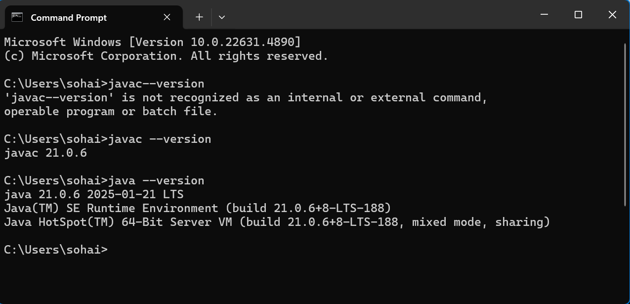

**PROGRAM-1**

**Aim:** To print name, roll no class and section..

**Program:**

class student_details{

public static void main(String[] args) {

System.out.println("NAME= Shaik Sohail");

System.out.println("ROLL NO= AV.SC.U4CSE24319");

System.out.println("SEC= B");

System.out.println("BRANCH= CSE");

}

}

**Output:** 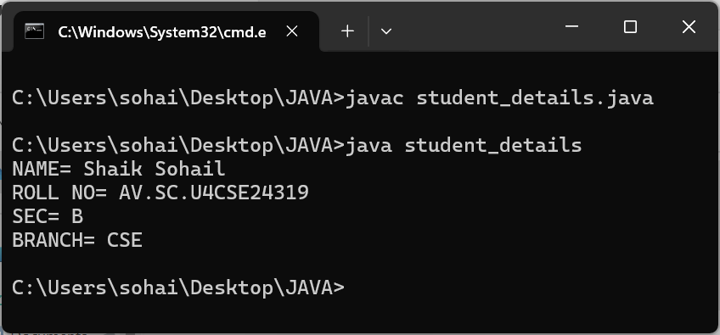

**Errors:**

|  |  |  |
| --- | --- | --- |
| SI.NO | Error Name | Error rectification |
| 1 | Syntax error | Placing ;(semi colon) |

**Important points:**

**WEEK-2**

**Aim:** Write a java program to calluclate the area of rectangle.

**Program:**

import java.util.Scanner;

public class area_of_rectangle {

public static void main(String[] args) {

Scanner scanner = new Scanner(System.in);

System.out.print("Enter the length of the rectangle: ");

double length = scanner.nextDouble();

System.out.print("Enter the width of the rectangle: ");

double width = scanner.nextDouble();

double area = length * width;

System.out.println("The area of the rectangle is: " + area);

scanner.close();

}

}

**Output:** 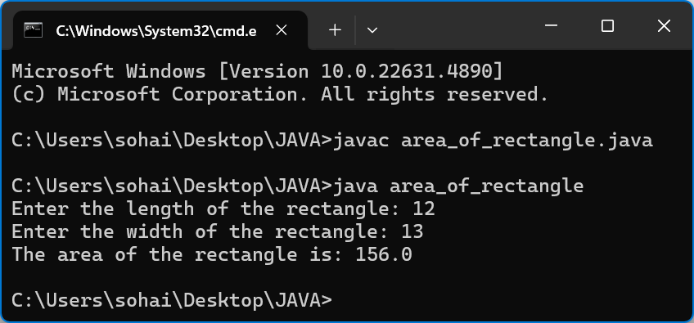

**Error:**

|  |  |  |
| --- | --- | --- |
| SI.NO | Error Name | Error rectification |
| 1 | Syntax erroe | Closing parentisis |

**Negative case:** The code dosent run when we give the input in text for

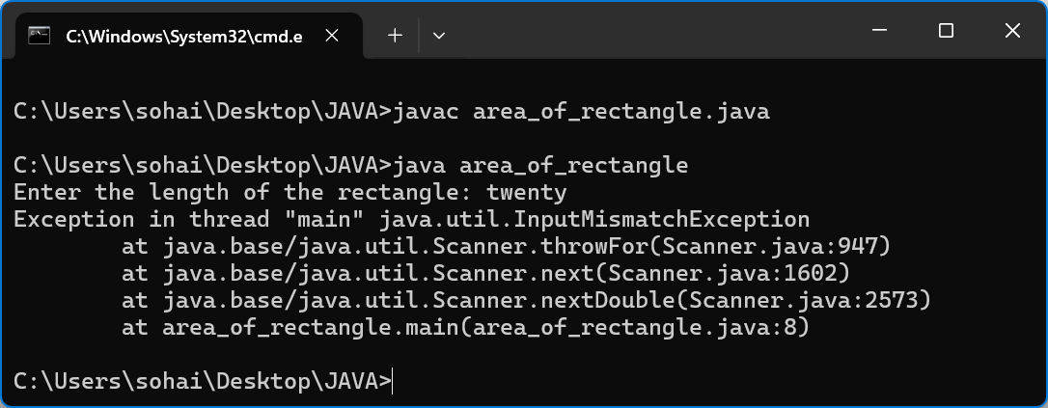

**Important points:**

**2.Aim:** Write a java programee to calculate celcius to farenheat anf vice verce.

**Programee:**

import java.util.Scanner;

class TemperatureConverter {

public static void main(String[] args) {

Scanner scanner = new Scanner(System.in);

System.out.println("Choose conversion: ");

System.out.println("1. Celsius to Fahrenheit");

System.out.println("2. Fahrenheit to Celsius");

int choice = scanner.nextInt();

if (choice == 1) {

System.out.print("Enter temperature in Celsius: ");

double celsius = scanner.nextDouble();

double fahrenheit = (celsius * 9.0 / 5.0) + 32;

System.out.println("Temperature in Fahrenheit: " + fahrenheit);

} else if (choice == 2) {

System.out.print("Enter temperature in Fahrenheit: ");

double fahrenheit = scanner.nextDouble();

double celsius = (fahrenheit - 32) * 5.0 / 9.0;

System.out.println("Temperature in Celsius: " + celsius);

} else {

System.out.println("Invalid choice! Please enter 1 or 2.");

}

}}

**Output:** 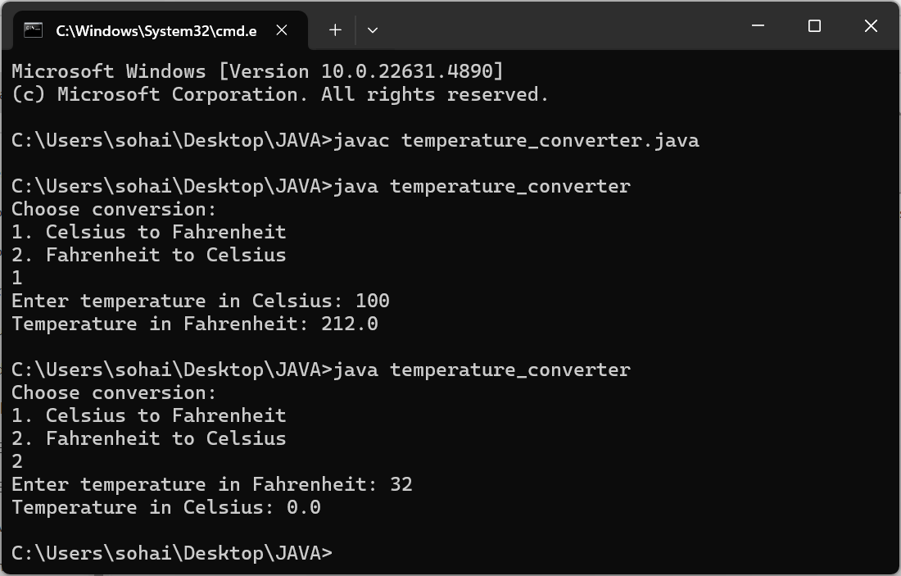

**Errors:** 2 errors

|  |  |  |
| --- | --- | --- |
| SINO | Error name | Error rectifiction |
| 1 | Syntax error | Placing == in the place of = |

**Negative case:**

**3.**

**Aim:** Caluclate Simple Interest using java programme

**Programme:**

import java.util.Scanner;

public class SimpleInterest {

public static void main(String[] args) {

Scanner scanner = new Scanner(System.in);

System.out.print("Enter the principal amount: ");

double principal = scanner.nextDouble();

System.out.print("Enter the rate of interest (in % per annum): ");

double rate = scanner.nextDouble();

System.out.print("Enter the time period (in years): ");

double time = scanner.nextDouble();

double simpleInterest = (principal * rate * time) / 100;

System.out.println("The simple interest is: " + simpleInterest);

}

}

**Output:** 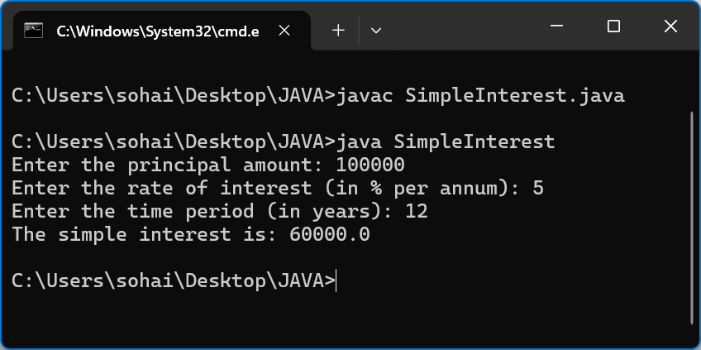

**Errors:**

|  |  |  |
| --- | --- | --- |
| Si.no | Error name | Error correction |
| 1 | Syntax error | Placing ; at end of ling double rate. |

**Negative case:**

**4.**

**Aim:**To find largest number of there numbers.

**Programee:**

import java.util.Scanner;

class Gratest_of_Three{

Public void main(String[]args){

Scanner scn=new Scanner(System.in);

System.out.print(“enter three numbers ”);

int a=scn.nextInt();

int b=scn.nextInt();

int c=scn.nextInt();

if(a>b &a>c){

System.out.println(a+“ is gratest );

}

else if(b<c & b<a){

System.out.println(b+“ is gratest”);

else{

System.out.println(c+ “ is gratest”):

}

}

}

**Output:** 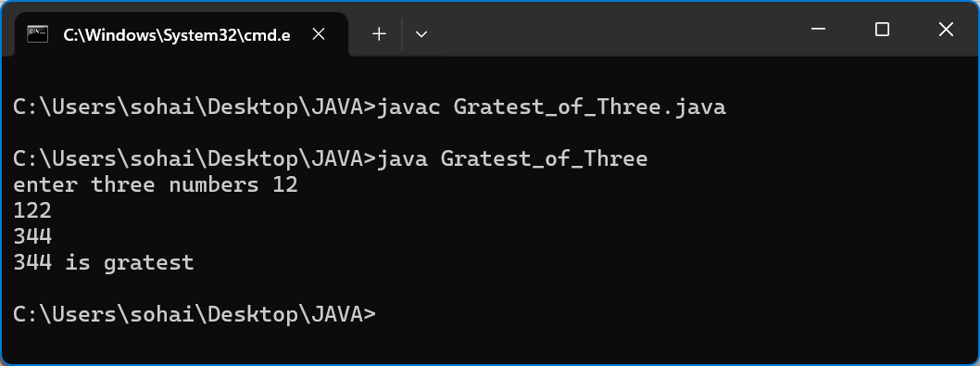

**Errors:**

No errors found.

**Negative case:**

**Important points:**

**Aim:** finding farctorial of a number using java.

**Programme:**

**Programme after rectification:**

import java.util.Scanner;

class Factorial{

public static void main(String[]args){

Scanner scn=new Scanner(System.in);

System.out.print("Enter the number: ");

int n=scn.nextInt();

int fact=1;

for(int i=1;i<=n;i++){

fact=fact*i;

}

System.out.println("factrioal of "+n+" is "+fact);

}

}

**Output:** 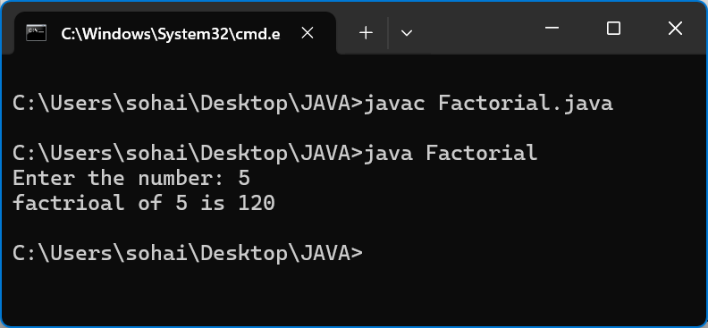

O

**Errors:**

|  |  |  |
| --- | --- | --- |
| Si.no | Error name | Error rectification |
| 1 | Identifier error | Changing ststic to static |
| 2 | Error in string literal | Changimg = to + in print statment |

**Negative case:**

**Important points:**

sssssssssss

**WEEK-3**

**Aim:**

**Programme:**

**Output:**

**Errors:**

**Negative case:**

**Important Points:**